Orkney Natural History Society Museum
Instituted 1837
Orkney Maritime and Natural History

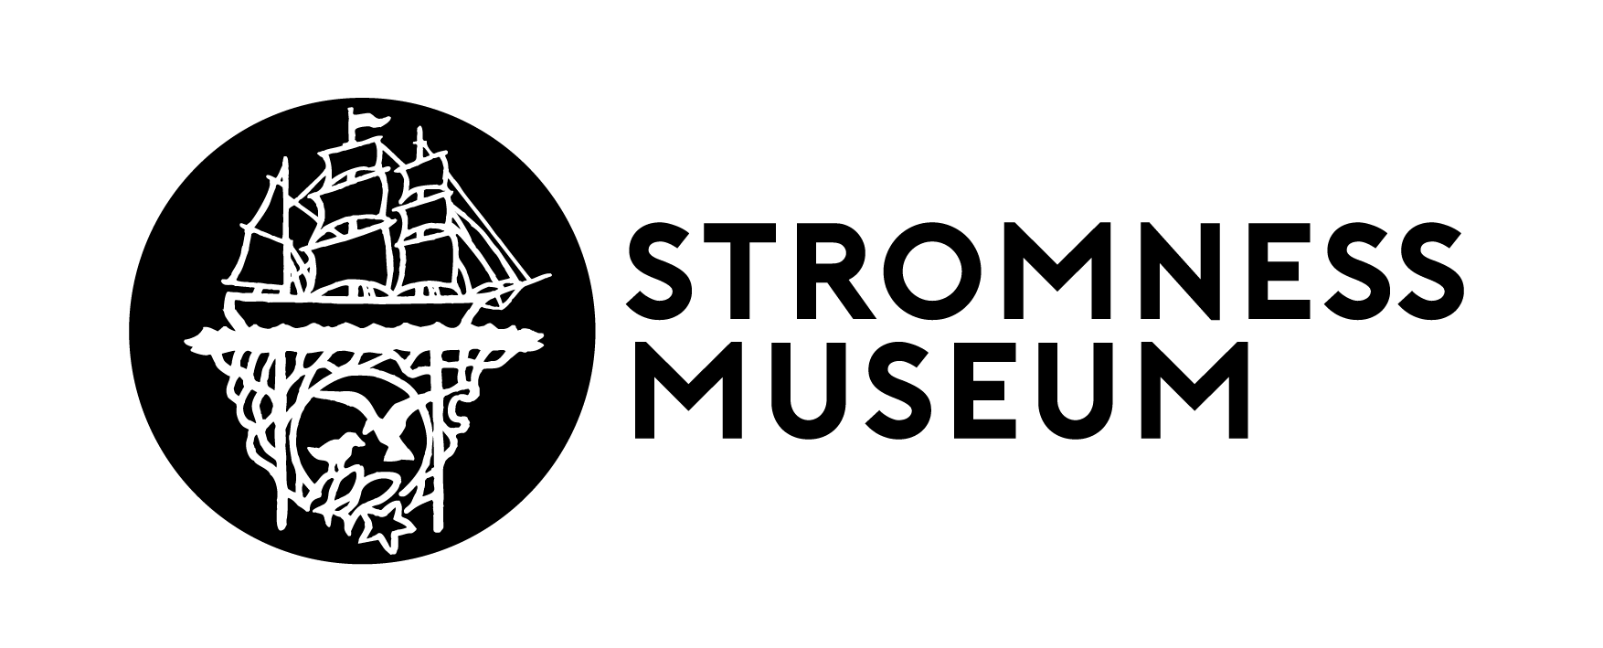

Stromness Museum, 52 Alfred Street, Stromness, Orkney, KW16 3DH: Tel: 01856 850025
www.stromnessmuseum.org.uk

The Annual General Meeting of the Orkney Natural History Society Museum
to be held on Tuesday 24 November 2020 at 6.30pm online, via Microsoft Teams
Click the link to join Click here to join the meeting

AGENDA

- Attendance
- Apologies
- Approval of minutes of the AGM of 26 November 2019
- Chair’s Report
- Treasurer’s Report
- Technical Manager Report
- Honorary Curator’s Report
- Annual fees
- Election of Trustees
- AOCB

